1.Write the program to solve the 8-puzzle problem

AIM
To write a Python program to solve the 8-puzzle problem using the Breadth-First Search (BFS) algorithm.
Objective:
To implement the BFS search algorithm in Python to find the sequence of moves that transforms the initial puzzle state into the goal state.

Algorithm
- Define the initial state and the goal state of the 8-puzzle.
- Place the initial state into a queue.
- Remove the first state from the queue.
- Check whether the current state is the goal state.
- If it is the goal state, display the solution and stop.
- Otherwise, find the position of the blank tile (0).
- Generate all possible valid moves (Up, Down, Left, Right).
- Add the new unvisited states to the queue.
- Repeat Steps 3–8 until the goal state is found.
- End the program.
Flowchart
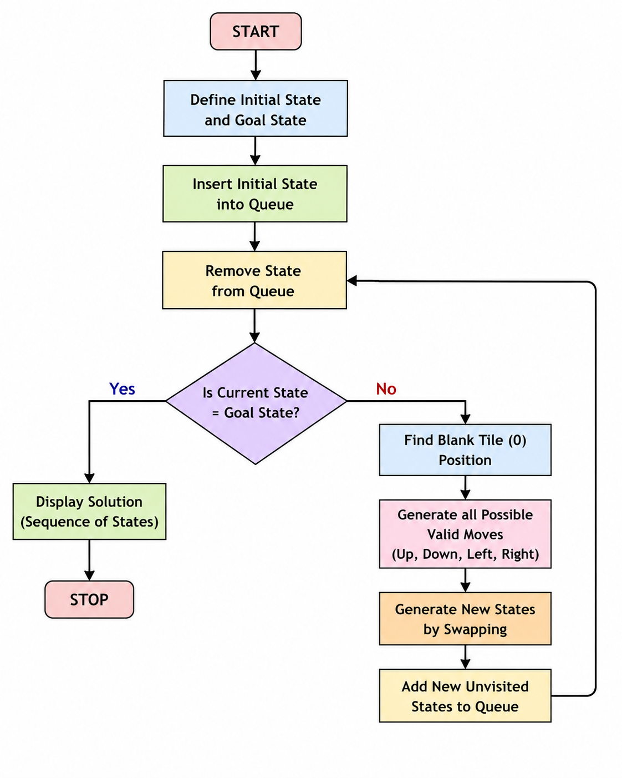

Code:

from collections import deque

start = ((1,2,3),

(4,5,6),

(7,0,8))

goal = ((1,2,3),

(4,5,6),

(7,8,0))

moves = [(-1,0),(1,0),(0,-1),(0,1)]

def blank(state):

for i in range(3):

for j in range(3):

if state[i][j] == 0:

return i, j

queue = deque([(start, [start])])

visited = set()

while queue:

state, path = queue.popleft()

if state == goal:

print("Goal Reached!\n")

for step in path:

for row in step:

print(row)

print()

break

if state in visited:

continue

visited.add(state)

x, y = blank(state)

for dx, dy in moves:

nx, ny = x + dx, y + dy

if 0 <= nx < 3 and 0 <= ny < 3:

temp = [list(r) for r in state]

temp[x][y], temp[nx][ny] = temp[nx][ny], temp[x][y]

new_state = tuple(tuple(r) for r in temp)

if new_state not in visited:

queue.append((new_state, path + [new_state]))

OUTPUT



RESULT: The Python program successfully solved the 8-puzzle problem using the Breadth-First Search (BFS) algorithm and reached the goal state by generating the required sequence of moves.

CONCLUSION

The 8-puzzle problem was successfully solved using the Breadth-First Search (BFS) algorithm in Python. The program explored the possible puzzle states and found the sequence of moves required to reach the goal state, demonstrating the application of AI search techniques in problem solving.

